# **Department of Computer Science and Engineering Islamic University of Technology (IUT)** A subsidiary organ of OIC

# **Lab Report 04**

# CSE 4412: Data Communication and Networking Lab

## 

## **Name:** **ROWSHAN MANNAN ONI Student ID: 210042145 Section: SWE Semester: SUMMER Academic Year: 2023-2024**

**Date of Submission:2/14/2024**

### **Title:** Understanding the basics of Inter-VLAN communication using Router, L3 Switch along with basics of Static Routing

### **Objectives**:

1. Design and implement Inter-VLAN routing using Router on a stick
2. Design and implement Inter-VLAN routing using Multilayer Switch
3. Understand and implement Static Routing

### **Diagram of the experiment:**

(Provide screenshot of the final network topology. Make sure to label the network components.)

**TASK 1:**

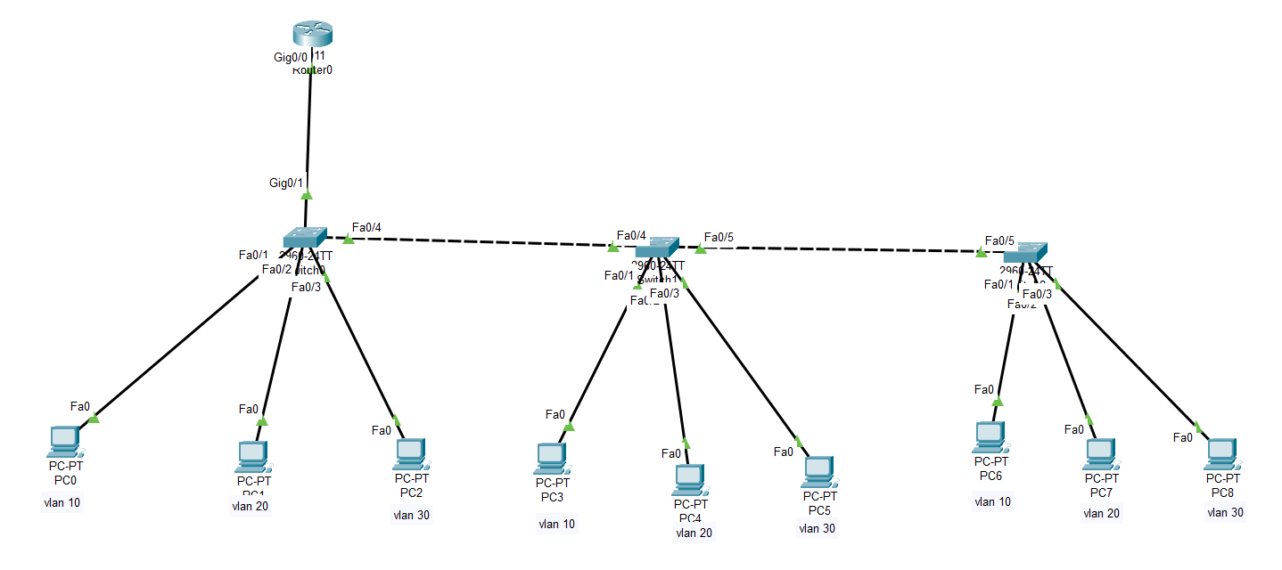

**TASK 2:**

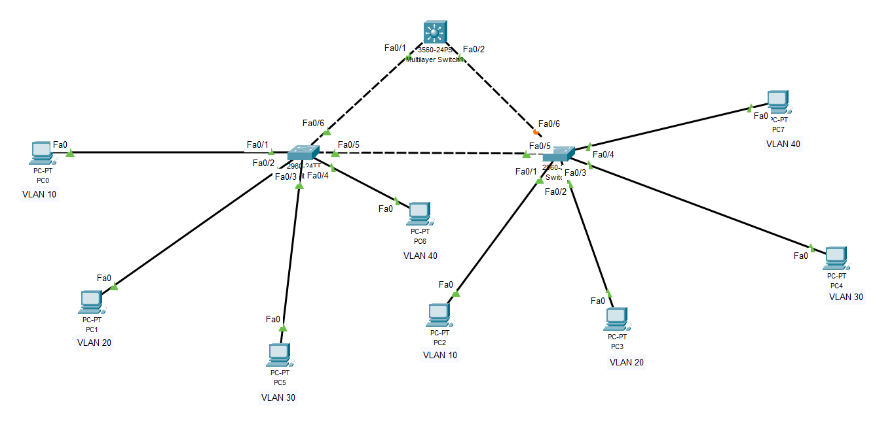

**TASK 3:**

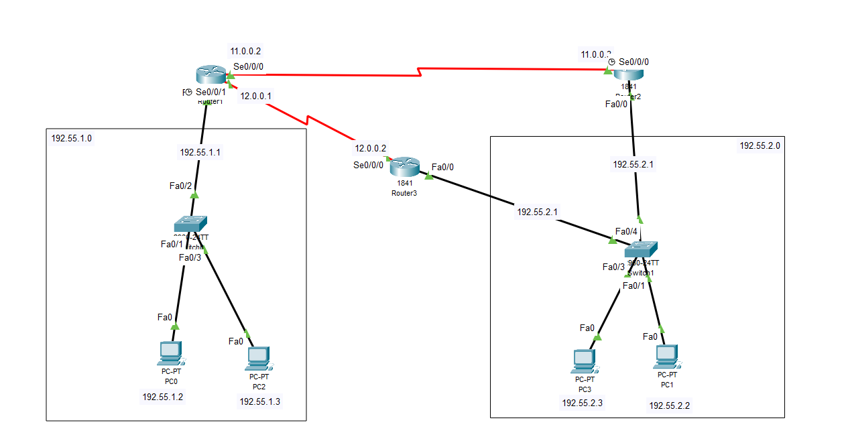

### **Working Procedure:**

**(**Explain in brief how you completed the tasks. Provide necessary screenshots of used commands for each task.)

**TASK 1:**

* + - 1. Create a new topology in Cisco Packet Tracer and add three switches and a router to the topology.
      2. Connect the router to one of the switches using a trunk port (configure the port as a trunk port on both the switch and the router).

1. Connect the other two switches to the first switch using trunk ports (configure the ports as trunk ports on all three switches).
2. Configure the switch ports on each VLAN as access ports (for example, configure VLAN 10 ports as access ports on VLAN 10, VLAN 20 ports as access ports on VLAN 20, and VLAN 30 ports as access ports on VLAN 30).
3. Assign IP addresses to each VLAN from the appropriate subnet (for example, assign IP addresses from the 192.168.45+10.0 subnet to VLAN 10, 192.168.45+20.0 to VLAN 20, and 192.168.45+30.0 to VLAN 30).
4. Create sub-interfaces on the router's interface connected to the switch for each VLAN (for example, create sub-interfaces for VLAN 10, VLAN 20, and VLAN 30 on the router's interface).
5. Configure the sub-interfaces on the router with the appropriate IP addresses and VLAN information (for example, configure the sub-interface for VLAN 10 with the IP address 192.168.45.10.1 and the VLAN ID 10).
6. Enable routing between the VLANs by configuring the router with a routing protocol (such as RIP or OSPF).
7. Test the connectivity between the PCs in different VLANs by pinging from one PC to another PC in a different VLAN.

Note that you will need to configure the IP addresses on the PCs in each VLAN and ensure that they are in the correct VLAN. You can do this by configuring the PCs with the appropriate IP address and default gateway (which should be the IP address of the sub-interface on the router for that VLAN).

**TASK 2:**

* + - 1. Create a new topology in Cisco Packet Tracer and add three switches and a multi-layer switch (Layer 3 switch) to the topology.
      2. Connect the multi-layer switch to one of the switches using a trunk port (configure the port as a trunk port on both the switch and the multi-layer switch).
      3. Connect the other switch to the first switch using trunk ports (configure the ports as trunk ports on all three switches).
      4. Configure the switch ports on each VLAN as access ports (for example, configure VLAN 10 ports as access ports on VLAN 10, VLAN 20 ports as access ports on VLAN 20, VLAN 30 ports as access ports on VLAN 30, and VLAN 40 ports as access ports on VLAN 40).
      5. Assign IP addresses to each VLAN from the appropriate subnet (for example, assign IP addresses from the 192.168.45+11.0 subnet to VLAN 10, 192.168.45+12.0 to VLAN 20, 192.168.45+13.0 to VLAN 30, and 192.168.45+14.0 to VLAN 40).
      6. Configure the multi-layer switch with a routing protocol (such as RIP or OSPF) to enable routing between the VLANs.
      7. Test the connectivity between the PCs in different VLANs by pinging from one PC to another PC in a different VLAN.

Note that you will need to configure the IP addresses on the PCs in each VLAN and ensure that they are in the correct VLAN. You can do this by configuring the PCs with the appropriate IP address and default gateway (which should be the IP address of the multi-layer switch for that VLAN).

**TASK 3:**

* + - 1. Add three routers (R1, R2, and R3) and two PCs (PC1 and PC2) to the network.
      2. Configure the interfaces on each router as follows:

**ROUTER 1**

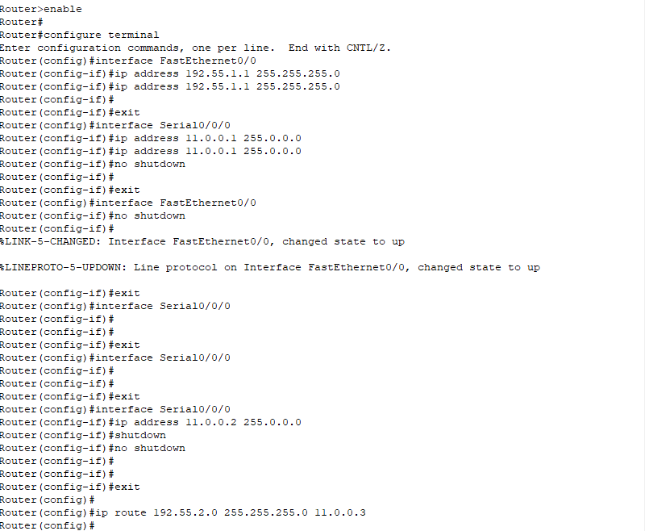

### **ROUTER 2**

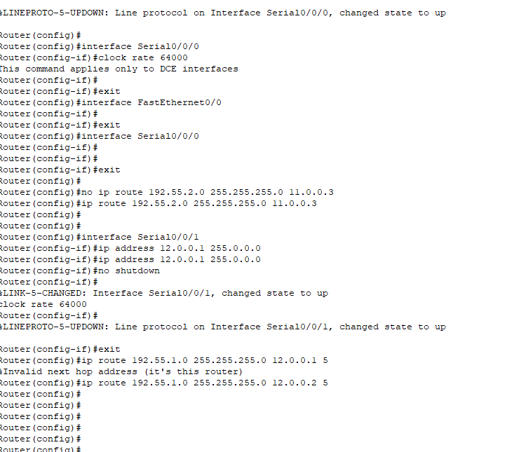

### 

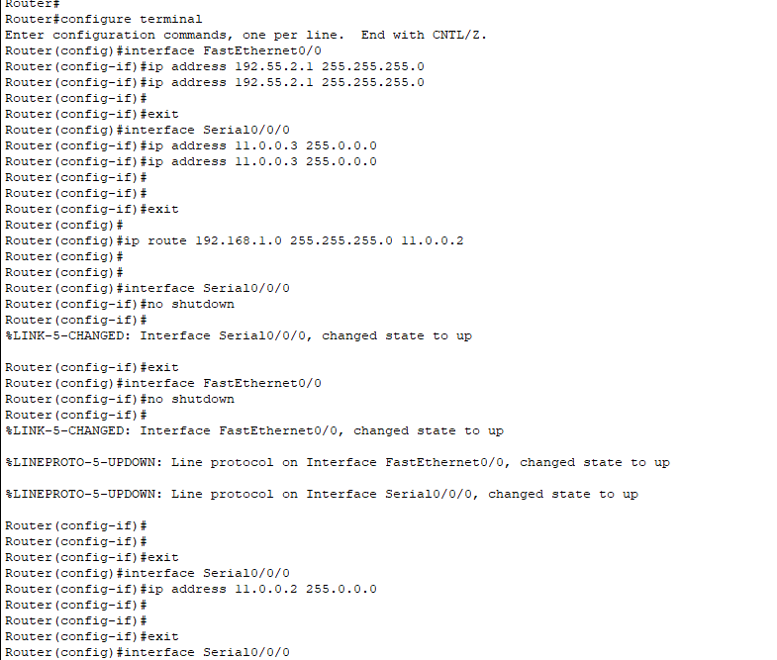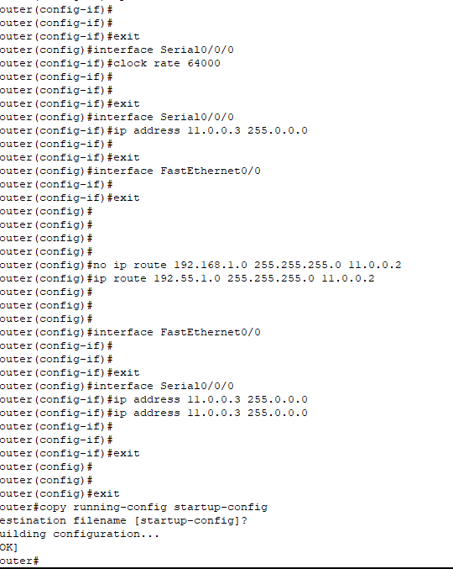

### **ROUTER 3**

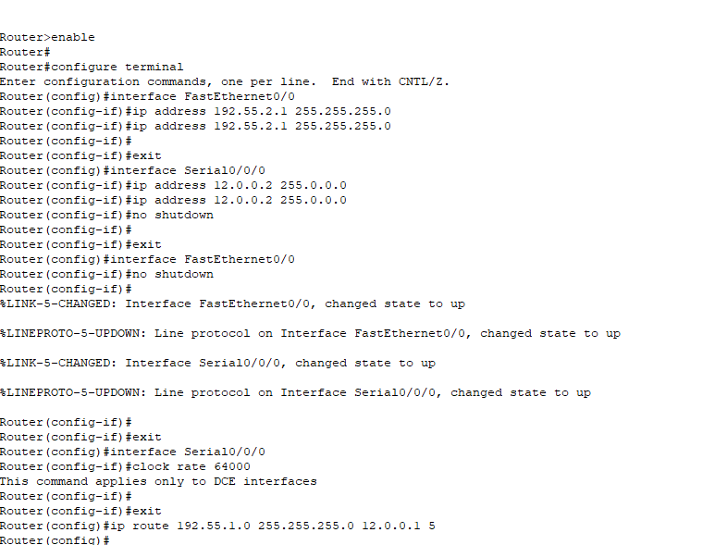

### **Questions (Answer to the point)**:

Why do we need L3 Switches?

**Ans:**

The need for L3 Switches in MLS (Multilayer Switches) arises due to the following reasons:

1. Faster forwarding: L3 switches use specialized hardware (ASICs) to perform layer 3 forwarding, making them faster than routers for large LANs.
2. Reduced latency: L3 switches perform layer 3 forwarding directly, without the need for additional hops through a router, reducing network latency.
3. Improved security: L3 switches can provide advanced security features, such as Access Control Lists (ACLs) and Virtual LANs (VLANs), to enhance network security.
4. Cost-effective: L3 switches are more cost-effective than routers for large LANs due to their faster forwarding capabilities and lower cost per port.

What is the use router in Inter-Vlan Routing?

**Ans:** The use of a router in Inter-VLAN routing is to enable communication between separate VLANs in a network. Each VLAN is considered as a separate broadcast domain, and routers are used to route traffic between these domains.

* + - 1. What changes are needed while configuring VLANs using L3 switches instead of Router-on-a-stick approach?

**Ans:** When configuring VLANs using L3 switches instead of the Router-on-a-stick approach, the main change is that the routing function is handled by the switch itself, rather than relying on a separate router. This is achieved by configuring the switch as a Layer 3 device, which allows it to perform routing functions between different subnets or VLANs.

**The steps to configure VLANs using an L3 switch are as follows:**

Create the VLANs on the switch using the vlan command. For example, to create VLAN 10 and VLAN 20.

Assign switch ports to the appropriate VLANs using the switchport access vlan command. For example, to assign ports 1-5 to VLAN 10 and ports 6-10 to VLAN 20.

Configure the switch interface as a Layer 3 interface using the no switchport command. For example, to configure interface FastEthernet 0/11 as a Layer 3 interface.

Configure the switch interface with an IP address for each VLAN, using sub-interfaces. For example, to configure sub-interfaces for VLAN 10 and VLAN 20 on interface FastEthernet 0/11.

Configure static routes or routing protocols on the switch to route traffic between VLANs or to other networks.

* + - 1. What is next-hop floating address?

**Ans:** In the context of static routing, a next-hop floating address is a backup route that is used only when the primary route fails.

* + - 1. What is the disadvantage of static routing?

**Ans:** The main disadvantage of static routing is that it does not adapt to changes in the network. When a network topology changes (such as when a link fails or a new network is added), the static routes must be manually updated to reflect the new conditions. This can be time-consuming and error-prone, and can result in network outages or reduced network performance.

### **Challenges (if any):**

### **Faced challenges at task 3, while creating the routing table for each router.**